**Experiment 6:-**

Design a digital display system (Liquid crystal display).

**Circuit diagram:-**

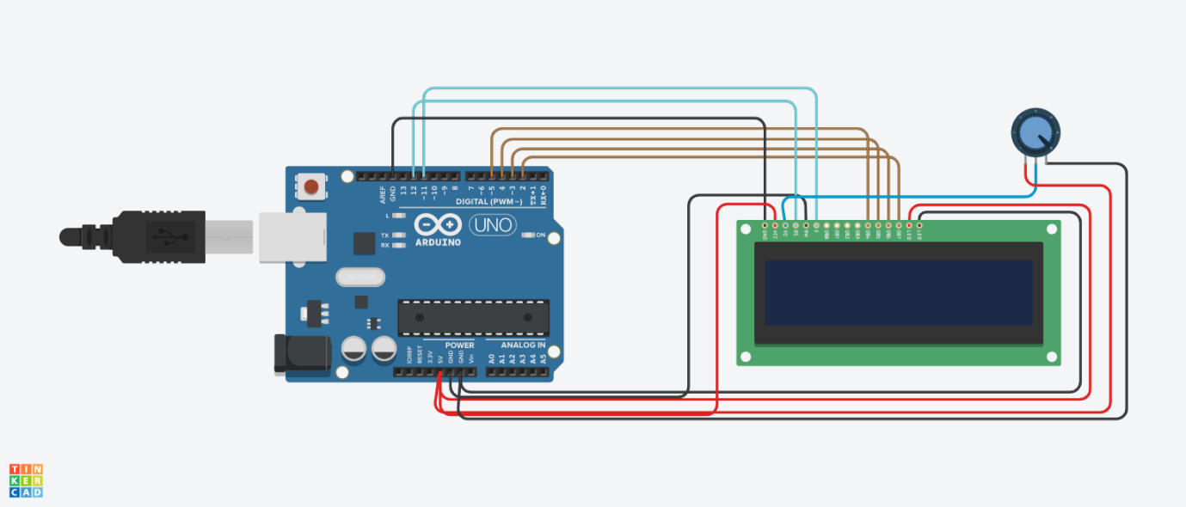

`

**Theory:-**

Concepts used in this project:-

LCD- liquid crystal display

It consist of 16 pins which are connected in the Arduino board as follows:-

* Vss = ground
* Vcc = +5V
* Vo = potentiometer middle wire
* RS(register select) = digital pin 12
* R/W(read or write) = ground
* E(enable) = digital pin 11
* DB0 – DB3 : Not in use
* DB4 = digital pin 5
* DB5 = digital pin 4
* DB6 = digital pin 3
* DB7 = digital pin 2
* LED+ = +5V
* LED- = ground

**Advantages:**

* Low power consumption
* Image is perfectly sharp at the native resolution of the panel.
* Zero geometric distortion at the native resolution of the panel. Minor

**Disadvantages:**

* Limited viewing angle.
* Black-Level, Contrast and Color Saturation
* White Saturation
* Aspect Ratio: LCDs have a fixed resolution and aspect ratio.
* Cost: Considerably more expensive than comparable CRTs.

**Applications:**

* Used in displays in digital wall clocks
* Used in digital cameras for displaying images
* All the digital wrist watches uses LCD screen for displaying time
* Calculator display screens are LCD screens

**Learning:-**

* I have learned through this project how to design a digital data display system using LCD.

**Observation:-**

* When we pass electrical signals through our code the LCD displays the stuff given in our code.

**Problems faced:-**

The problems I faced:-

* The circuit was not working because the connections were not proper.
* The breadboard was broken.

**Precautions:-**

The precautions that should be taken while doing this experiment are:-

* The connections should not be loose.
* Every stuff should be joined at their appropriate place and it should be properly closed.
* The code should be written properly.

**Learning Outcomes:-**

* I have learned how all the hardwares should be connected to make them work in a proper condition.
* I have learned how an LCD works practically.